**AWS CLI CONFIGURE**

**AWS CLI CONFIGURE**

* Firstly we download aws cli in our system
* Then we configure it to use this command

aws configure

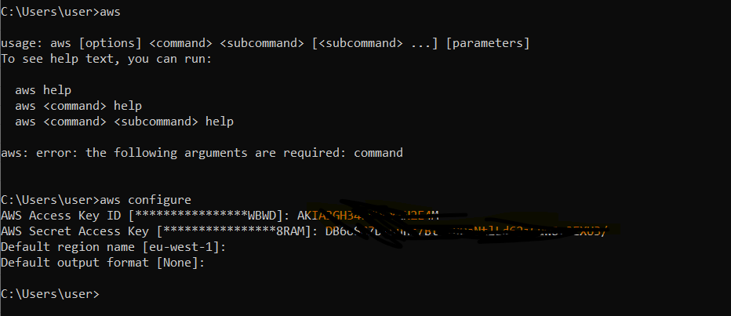

* We see our Ubuntu instance is running mode

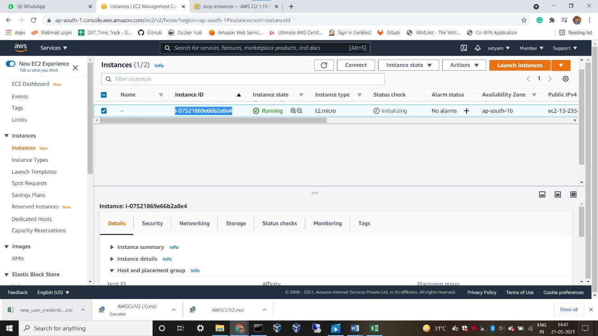

* Now we use this command to stop our instance

C:\Users\user>aws ec2 stop-instances --instance-ids i-07521869e66b2a8e4

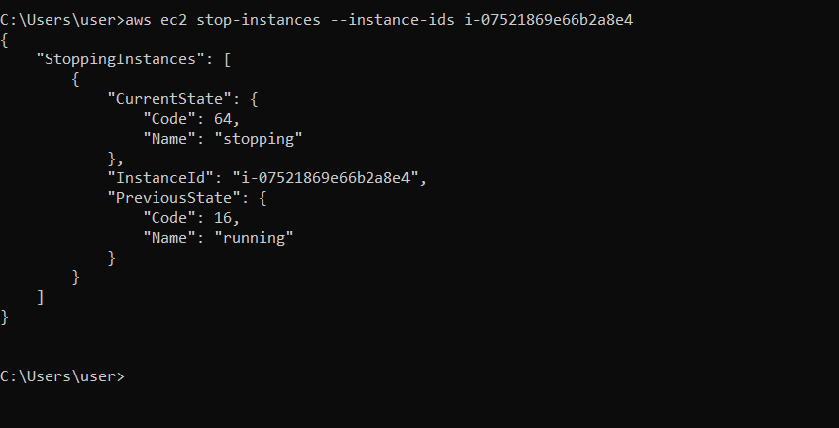

* Now, We see our instance has stopped

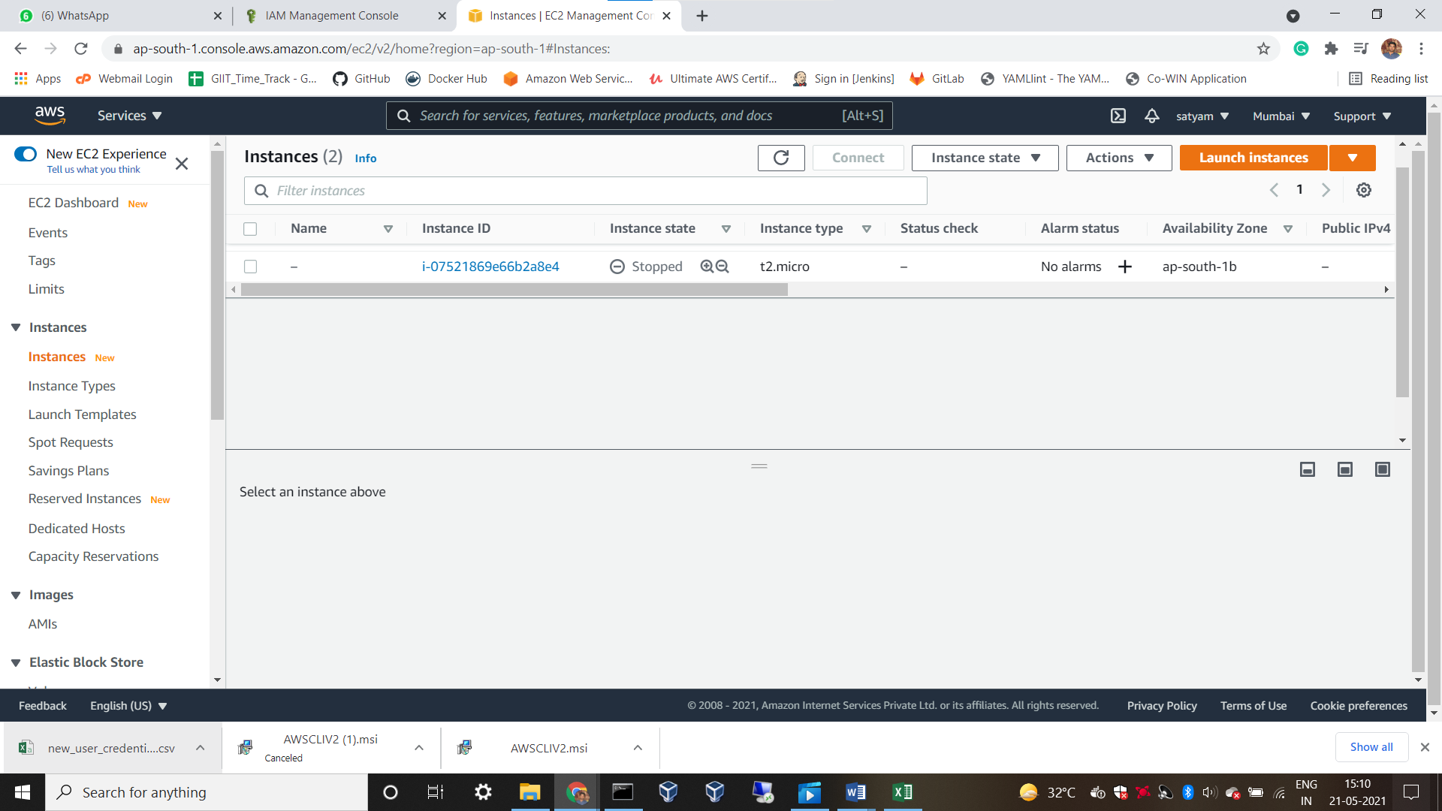

* Again we want to start our instance we use this command

C:\Users\user>aws ec2 start-instances --instance-ids i-07521869e66b2a8e4

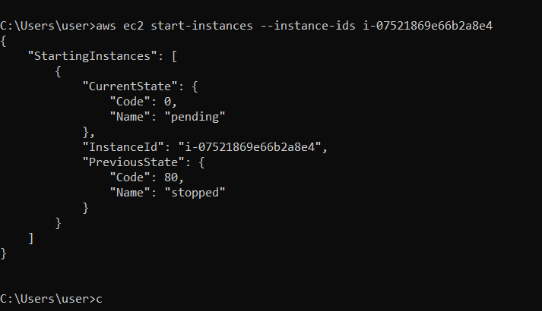

* Start & Stop both

